Breakthrough Awards – NRC Report Instructions

**Patient Experience HCAHPS**

1. A screenshot of a computer

   Description automatically generatedSelect “**HCAHPS**” from “**My Reports**” and “**On Demand Reports**” from “**My Tools**”:
2. 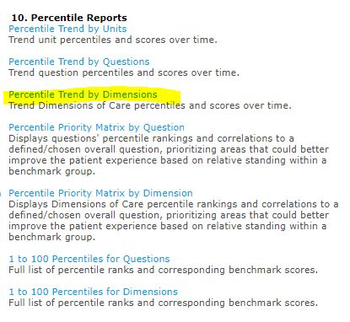Scroll down to “**Percentile Reports**” and   
   select “**Percentile Trend by Dimensions**”:
3. Two reports are run:

* July 2021 – June 2022, and
* July 2022 – June 2023



*Breakthrough Awards – NRC Report Instructions (cont’d)*

*Breakthrough Awards – NRC Report Instructions (cont’d)*

1. 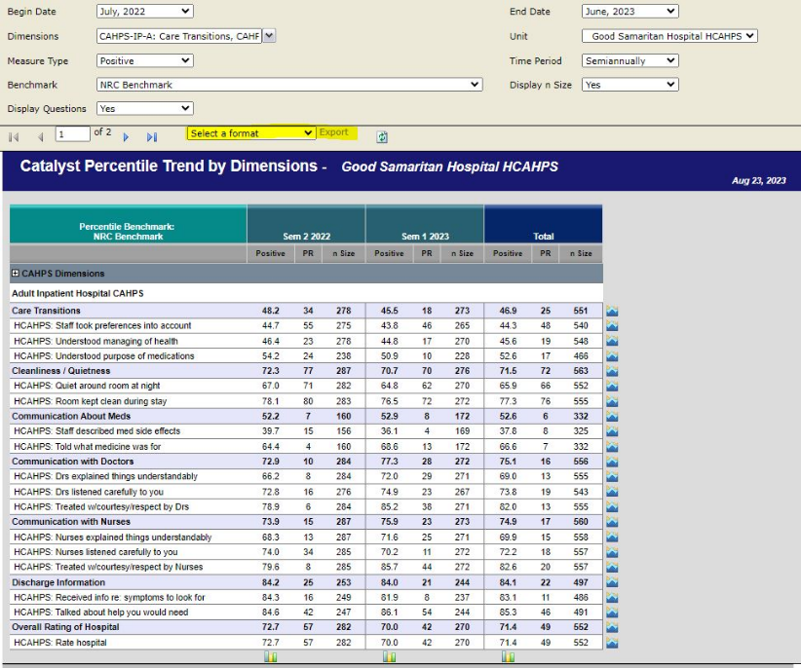**Select a format** from the dropdown menu that you would like the report in and click “**Export**”:

**Patient Experience ED CAHPS, CG-CAHPS, OAS, & HH CAHPS:**

1. A white background with orange text

   Description automatically generatedSelect “**Benchmark**” from “**Standard Reports – Experience Overview**”:

*Breakthrough Awards – NRC Report Instructions (cont’d)*

1. Select your Service Line from “**Question Pods**” and select the date range.   
     
   Two reports are run:

* July 2021 – June 2022, and
* July 2022 – June 2023:

1. **Export** the report(s):

