Breakthrough Awards – Press Ganey Report Instructions

1. Select **Services** and **Sites** for all surveys to be submitted.

1. Select **“Overall**” option for each domain from each survey, not individual questions.

1. Under **Filters & Groups: Report Period** select your period as “**Custom**.”

Two reports are run:

* July 1, 2021 – June 30, 2022, and
* July 1, 2022 – June 30, 2023

*Breakthrough Awards – Press Ganey Report Instructions (cont’d)*

1. Under **Options and Format: Data options** select “**Mean**” for “**Press Ganey**” questions and **Top Box** for **CAHPS** questions. Display the “**n**” size on all reports. Check “**Enable CMS View**” and “**Skip Logic**”.

1. A. Under **Options and Format: Benchmarking** select **BENCHMARK OPTIONS - PEER GROUP** “**Score**” and

“**Percentile Rank**.” Select **Peer Groups** as “**All PG Database**” on all options.

B. Select **Benchmarking** as “**All Respondents**” on all options.

**B**

**A**

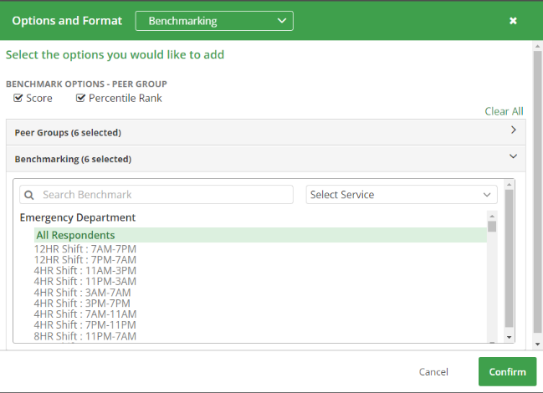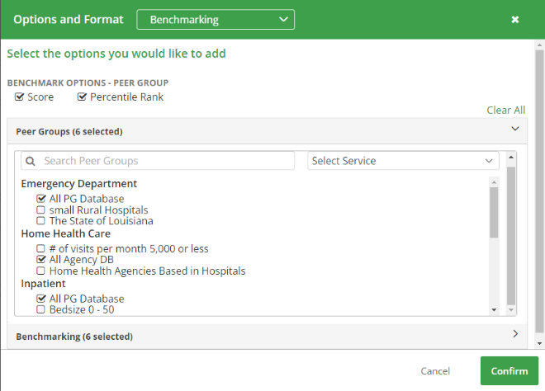

1. Save your report so that it can be used each year. You will run two reports each year:

* One for the prior year (July 1, 2021 – June 30, 2022), and
* One for the current year (July 1, 2022 – June 30, 2023).

This format will run in one report all survey types and calculate “Top Box” for CAHPS questions and “mean” for your PG questions. It will automatically run the national average for your CAHPS questions and percentile rank for the PG questions as requested by CLS for the Breakthrough Awards.